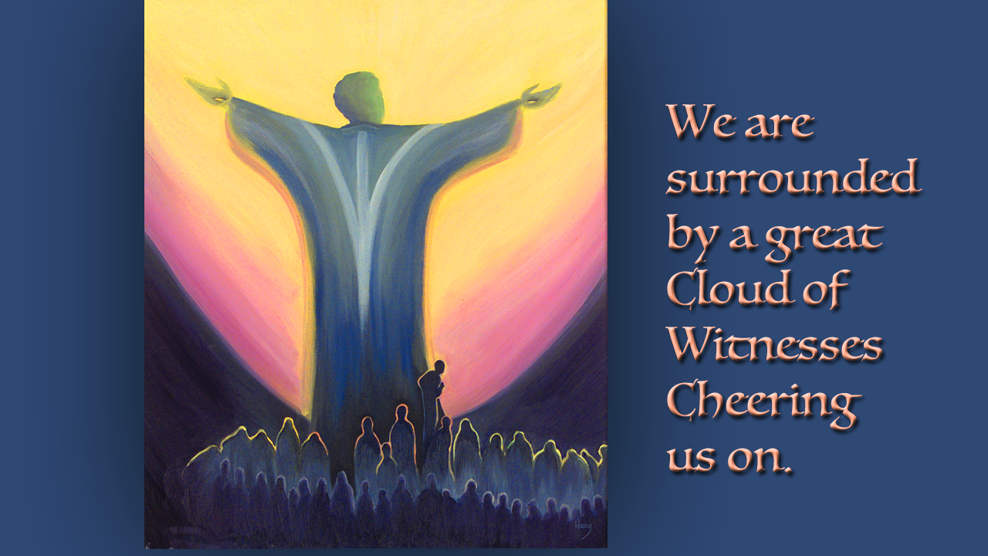
The Cloud Attends a Lord’s Supper
April 15, 2019

You never cease to amaze us, Lord! Please continue. We love these wonderful forays into YOUR world, as we climb higher and higher up the Mountain of Holiness with You. Your ways are so high above us, but we rejoice in every new adventure You bring us on. Help us, please, continue our unique and individual climbs with You? So that we may be fully pleasing and joined with You in our lives, serving the Kingdom and becoming more and more united with You, each day. Amen.

Well, dear Heartdwellers. We have another testimony from our Prayer Team to share with you today. This is from one of our women priests.

She begins, “I had this experience two nights ago, celebrating the Lord's supper. I was alone in my celebration, for the first time in a while. And to tell you the truth, it felt a bit strange. I often have my prayer buddy with me, and/or some others, who simply want to receive Communion and celebrate the Lord's Supper. (I had been joining others on Skype to have communion together.) And now, for the first time in quite some time, I found myself alone with our Lord.

“Or so I thought.

“Before beginning, I ask the Lord to direct each Mass and guide it, so that all receive what they need, as per His Will. And so that we are all able to glean His wisdom from the readings chosen by Holy Spirit that day. At the very beginning of this celebration, I found myself, surprisingly, asking if there were any other souls, from anywhere, who would like to attend this celebration of the Lord's Supper?

“Please know that I have NO idea where that request came from!

“I asked this, and I had this strangest "knowing" that others were, indeed, present. I sensed that some were from the Cloud of Witnesses, and others were souls from around the world, whom the Lord had chosen to attend this Mass.

“In the portions of the Mass where there is either a respondent or respondents, or the priest reads this portion aloud themselves if alone, I suddenly heard the voices of others repeating after me or speaking the words of the respondents! For example, in the Kyrie Eleison. I would speak as the priest and say, "Lord have mercy." Normally, when alone, I would then repeat this phrase, as the respondent. However, in this case, I clearly heard voices of others responding in my place... as they should respond. For they were present!

“I could feel the presence of the Holy Spirit everywhere. My body was tingling; My hair would stand up on end. I felt joy... and a sense of being overcome by love. When I have felt this kind of love before, it is like nothing that I can describe on Earth. I have only felt this kind of love in the presence of the Lord or our Blessed Mother. I usually begin crying immediately, but I am not grieved. It is different, and in many ways inexplicable. At least, I do not have the words to describe it properly.

“Later in the celebration, I prayed with Holy Spirit in tongues, but I am uncertain what we prayed for. I felt like we prayed for the world in some way. But I was not privy to the details. I know that we were joined in our prayers by those who were with us, whose presence was palpable.

“I was then prompted to ask the Lord to have His angels carry either prayers of absolution or prayers of extreme unction throughout the world, to the souls He knew needed them. These are considered a plenary indulgence. IF the soul repents, then all sins are forgiven. Extreme Unction is often given to the very sick or to those who cannot respond and actively repent at the time this prayer is said over them. I also had the "knowing" that some of these prayers were being stored in Heaven, to be used at a later date, whenever it is that the Lord deemed them needed.

“After I took priestly communion (this is right before Communion is given out to others), I asked the Lord again (thanks to His love and mercy) to have His angels take spiritual Communion to all souls around the world. To those who were in a state of grace to receive, but who could not for whatever reason. (Perhaps there was no priest nearby, or perhaps they were ill or in a coma, and so on.) And I know that this occurred! I also felt in my heart that some of the souls who had joined our celebration also partook of spiritual Communion. How amazing is our Lord!

“What I thought would be a quiet and lovely Mass, shared with my beloved Jesus, turned into something quite different and extremely unexpected. I have never considered asking other souls to join me. In truth, it's never even occurred to me. That is one of the ways that I know that this was Holy Spirit's intervention! This Mass felt different, as well!

“In general, I find celebration of the Lord's Supper to be the highlight of my day! And I have shared many wonderful experiences during these times. But I have never had this experience before.

“And I realized that, because of my own short-sightedness, it could be that I may lose out on many opportunities. Simply because they would never occur to me. But if I listen carefully to the suggestions of the Lord. Confirm, yes—but do not doubt. And go forward in faith, then amazing things can happen! Things I would never consider!

“I find that He has the ability to use us in so many ways that—at least to me—are absolutely outside of my realm of thought or consideration! If we are willing, how much more will we be exposed to? I can only imagine. I will remember the profound love I felt during this celebration. The Holy Spirit shivers I received as these prayers and spiritual communions were given to other souls in need. The joy I felt from the souls who joined me in thanks, prayer, and worship!

“I do not have a good sense of how many joined the celebration; nor do I think it matters. But it is on my heart to say that I don't think space in our realm means much to the Lord... And that we may be hosting many more than we know. All we can do is offer.

“I want to serve. But, very often, I do not know how BEST to be of service. And, lately, it has been on my heart that, just as prayer and warfare are changing, and it is best to ask our Lord and Army general, Jesus, how best to handle each situation. So, too, is it in these and other circumstances.

“I may not know how to handle a circumstance, such as how best to serve, at a particular moment. But I know that the Lord knows how to address this matter, and how I can best serve Him. I only have to ask Him.

“I am only just receiving my sight back, after 6 years. And I am learning to hear and so on again, too. I used to worry about the fact that I couldn't hear anything or see anything that He communicated to me! Then, He put it in my head (of course) that I do not NEED to worry... Because He is the Lord; and He can do anything! He can certainly help me to comprehend Him.

“I just need to ask, humbly, and with pure motive to serve.

“In this case, there was no reason He would say ‘no’. In the past, I suspect that my motives were not so pure. I have no doubt that I've also had thoughts, like, "Boy, that would be cool!" Or some other such thing. I'm sure I wanted to serve Him, too—but I also thought it would be really amazing! Those kinds of thoughts, for me, give way to pride or bragging, which could lead to spiritual envy. In other words, nothing good comes of them.

“But a pure desire to serve, in whatever way He wishes, may be a prayer that He Is quicker to answer with a ‘YES’.”

And that was the end of her testimony.

May the Lord bless you richly today, dear Heartdwellers.

